Ulster County Votes 2024
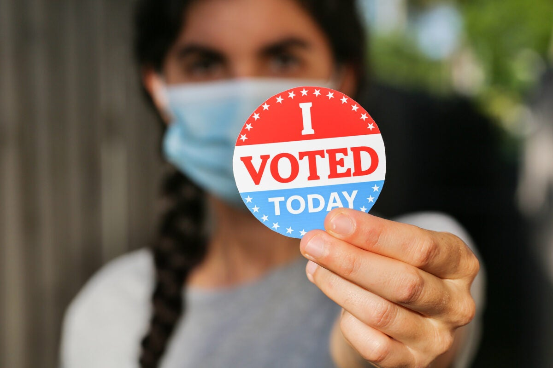

I Voted Stickers are a popular way of showing your civic pride and reminding your neighbors to vote!
Show us your ideas!!
Finished designs will be shrunk to this size –
2 inch circle

The Ulster County Board of Elections 4th Annual Ulster County Votes
WHO: Any young person, age 9-18 that is a resident of Ulster County can participate.
WHAT: Design a logo that we will use to create “I Voted” 2 inch stickers and digital graphics that can be used for sharing for the November 5, 2024 General Election. I Voted must appear somewhere in the design, but the rest is up to you.
WHEN: Artwork will be collected between the period of April 1, 2024- June 1, 2024. The Ulster County Board of Elections Commissioners will select the top designs and then – of course – we open the contest up to voting on the top designs on our website. During the month of July visit VoteUlster.com to cast your vote for your favorite design. The winning artwork will be selected from the top vote getters and announced on September 9, 2024. Stickers will be distributed during the November 5th General Election to all voters in Ulster County.
HOW: Send your artwork – Photo, PDF, JPEG to Elections@co.ulster.ny.us
For more information please contact: Deputy Commissioners Jen Bloom or Keri Williams 845.334.5470
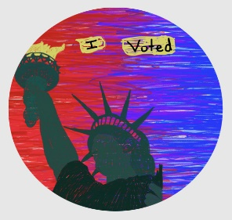
Voteulster.com
